Matrix – Ctf – Write up

We start out jouney in the http://matrixctf.unaux.com:
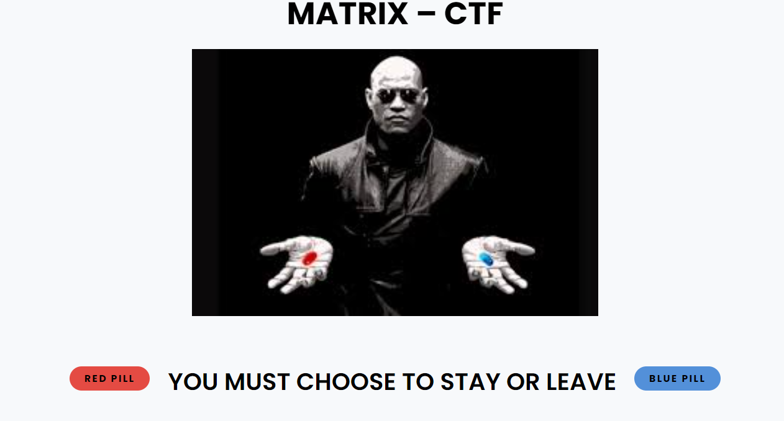

We understand from the video and the story we need to decide if we want to do the ctf – take the red pill, or wake up in our bed – taking the pill.
So we take the blue pill. Because 2:00 am is a bit to late to start solving the ctf. Good night!
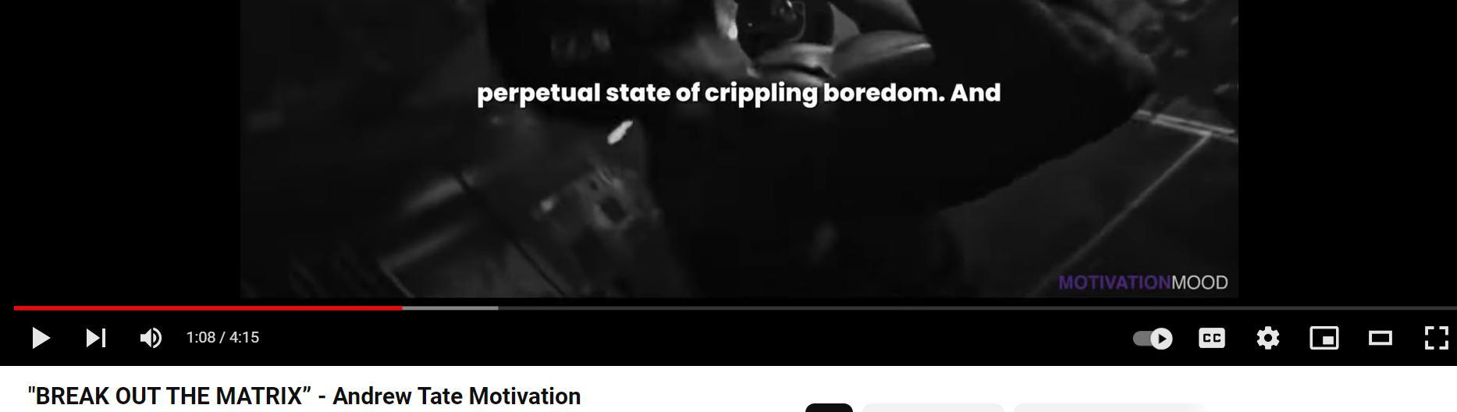

But after the amazingly motivating video if breaking out of the Matrix. I decide that sleep is for people in the matrix and if I want to grow ill need to break out of the matrix.
So I press on the red button:
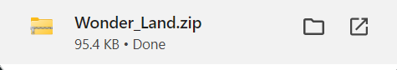
I get a zip folder, and if we unzip it:
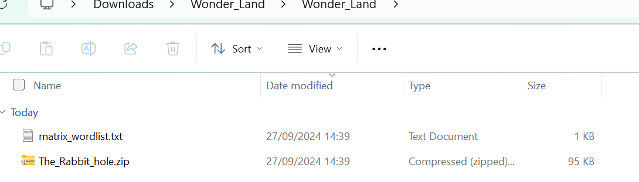

The txt file contains a couple of words, and a hint to what the password might be.
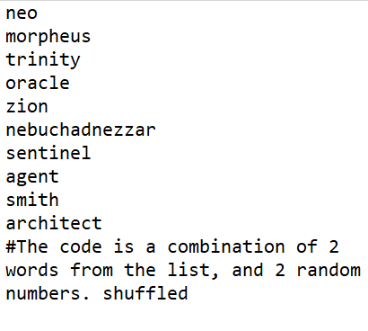
The zip file “the rabbit hole” has these two files:
But when I try to open them:
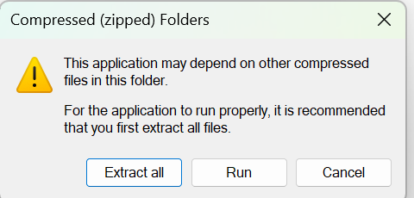
And when extracted, we encounter this problem:
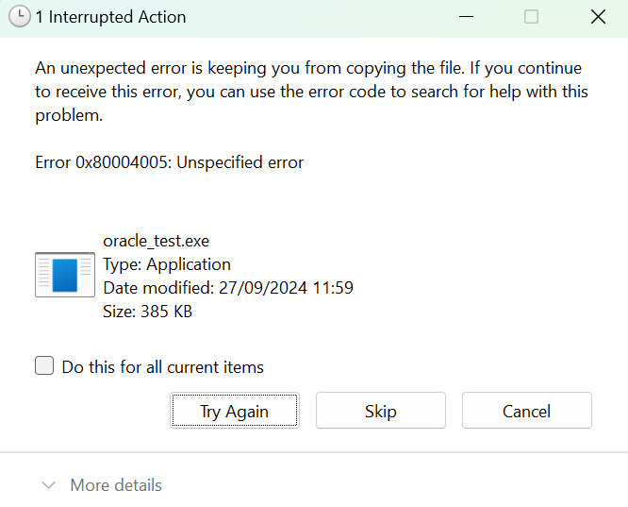

So we try to use “Win rar”
and we discover that the file has a passcode on it:
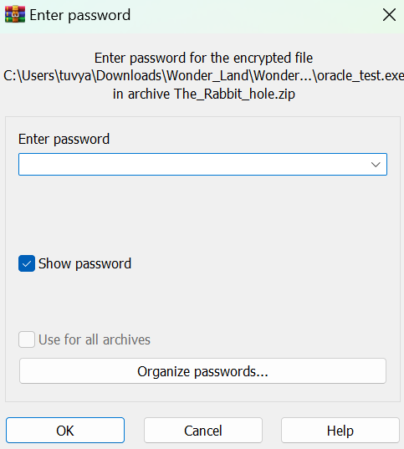
So we now we understand that the txt file was talking about the password for the zip file, so we go and learn how to write a python code in relationship to zip files, and with the hint we got from the txt file:
Crack_rabbit_hole.py
And after running we get:
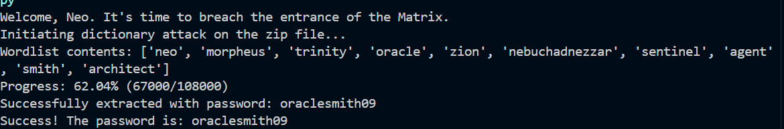
So the password is:
oraclesmith09
So lets go and extract the files in the zip:
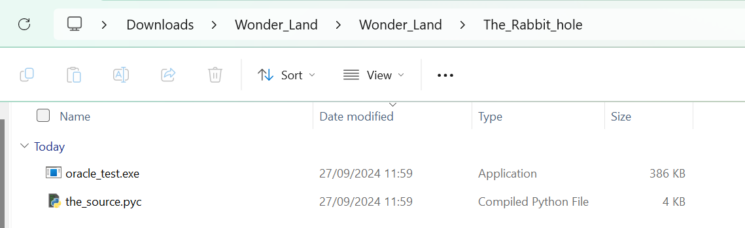
So when I run the_source I get this:
ok, looks like a http server using post. But I have no idea what the password is.
Lets see the exe file:
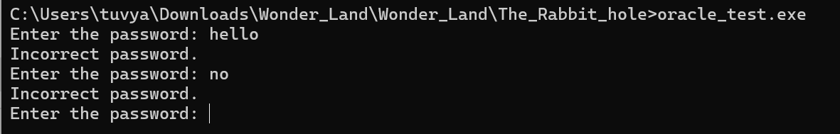
It looks like its asking for a password, so lets open the exe file in ida and see what we have:

Breaking the exe file:
When we open the exe file we could see its really complicated with a lot of anti-debug functions.
We look in the data sections, nothing the resembles a password.
So there are two ways to find the password:
- Because the password is a string class, so you can’t see it in the data section without running the code and debugging. But we can clearly see there’s a lot of antibug.
- To patch the if:
So lets look for the “If” that takes care of the password to see if its correct.

We look for the main:
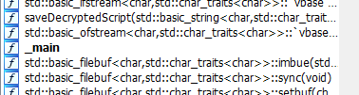

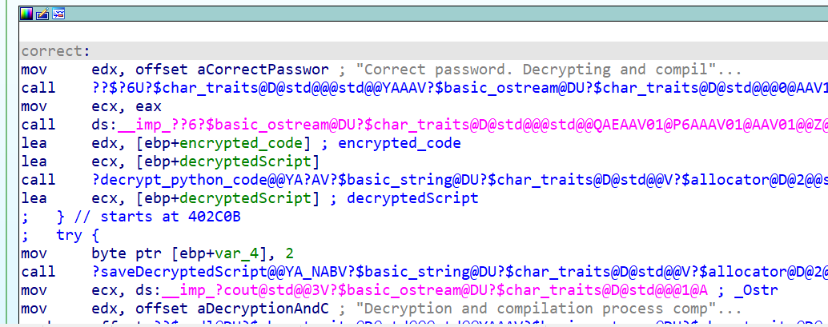
We find the correct password box, and we rename it “correct”:
And we path the program so even when the password is wrong itll go to the the correct label:
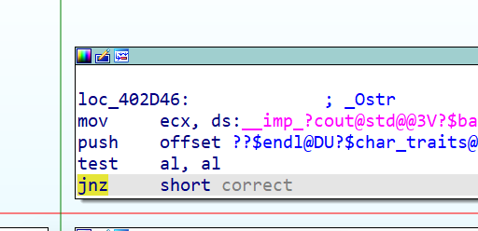

To:
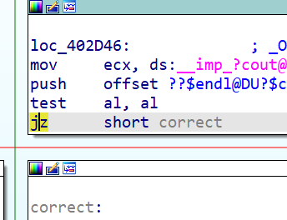
And now when we run it:
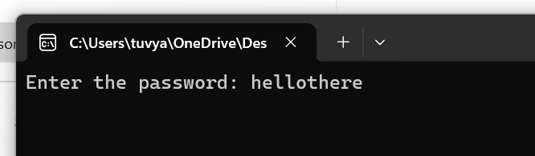
the program runs and we can see in our folder we have a new file:
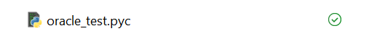
So lets run the new pyc we just got:
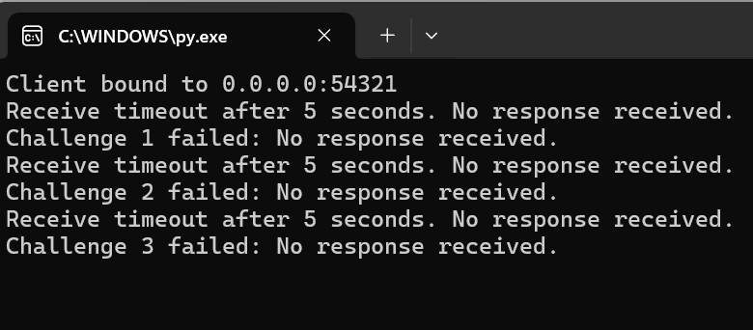
So we can clearly see that the code is probably a client that send something to somewhere and is waiting 5 seconds for a response.
Lets open Wire-shark:
We understand that its sending udp packets because there’s no evidence of a handshake, and we guess we should use the wifi.
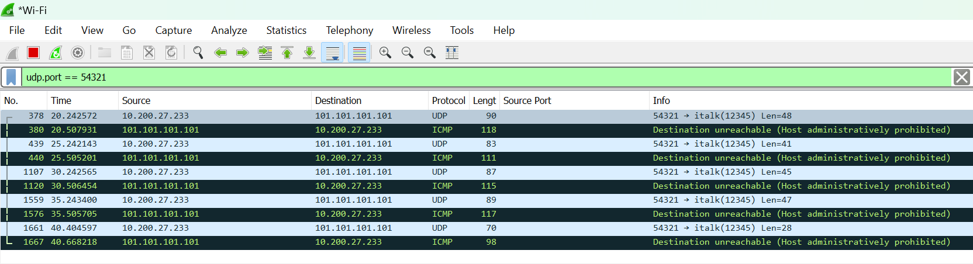
We see that the client is sending 5 challenges to the ip : 101.101.101.101, and port: 12345 , and waits for an answer.
So, we’ll write a server to answer the challenges.
(we can see the challenges in the data section of the packets: 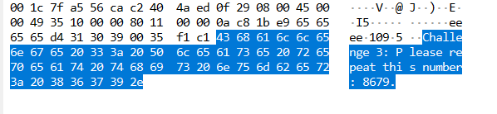)
While writing the code we understand that we need to sniff and snoof the packets, because the client is expecting the answers to come from the ip it sent to.
So well use scapy:

The full code: NetworkAnswer.py
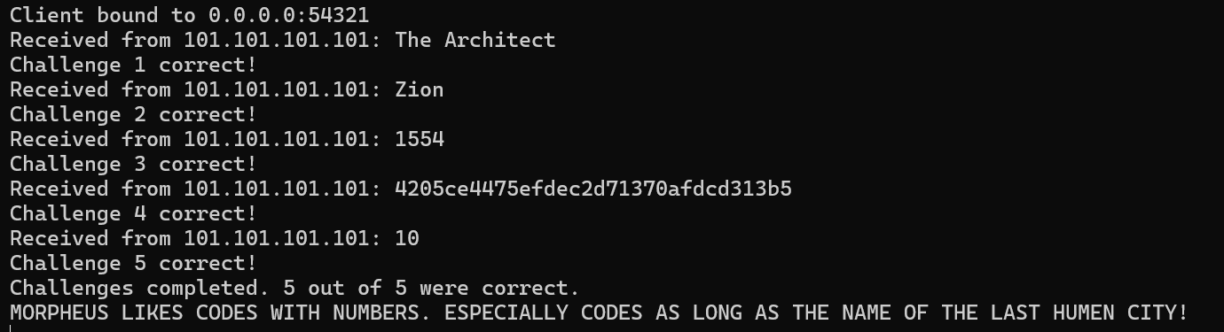
We got a hint for a password, probably for the the_source.pyc, the hint just says that the code is a 4 digit in. so lets write a http client to brute force server:
The full code: http_cracker.py
And we find that the code is: 1999 (the year the Matrix came out_)
and we can see we get a http link to the protocols:
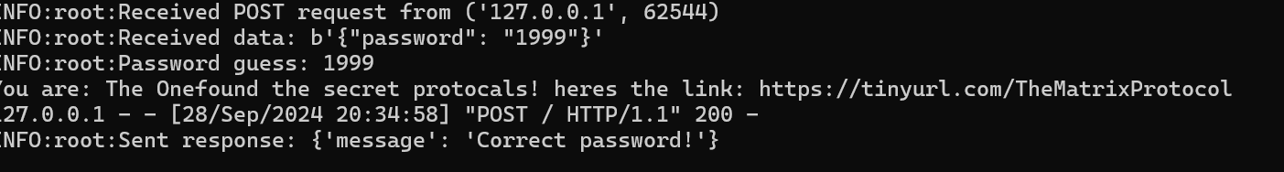
And if we open the link to see the protocols:
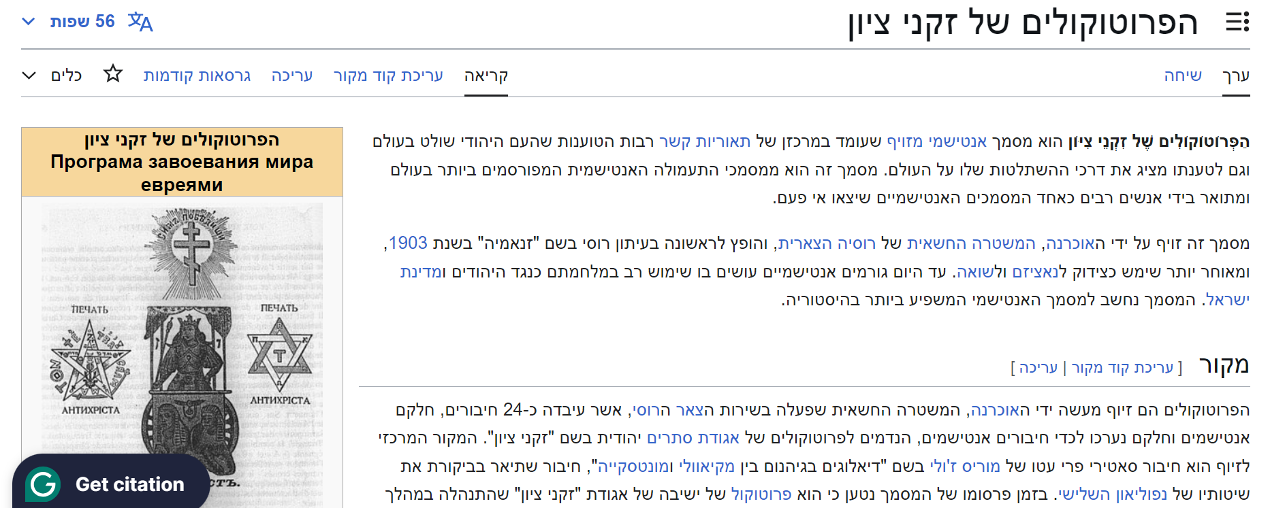

We found the protocols of the Matrix!!!

